* 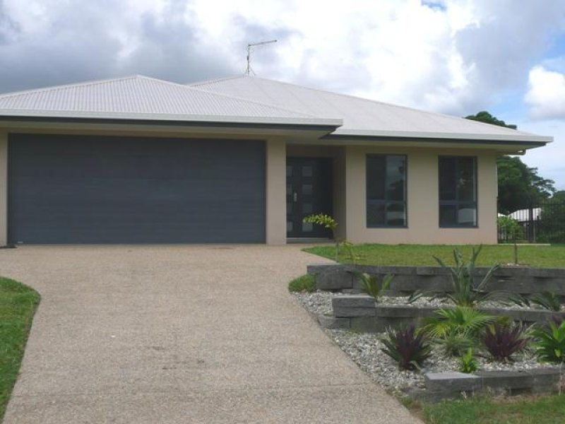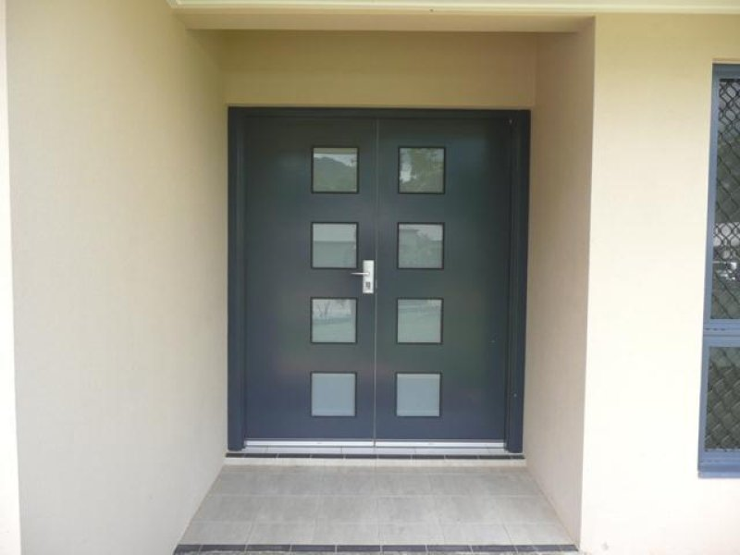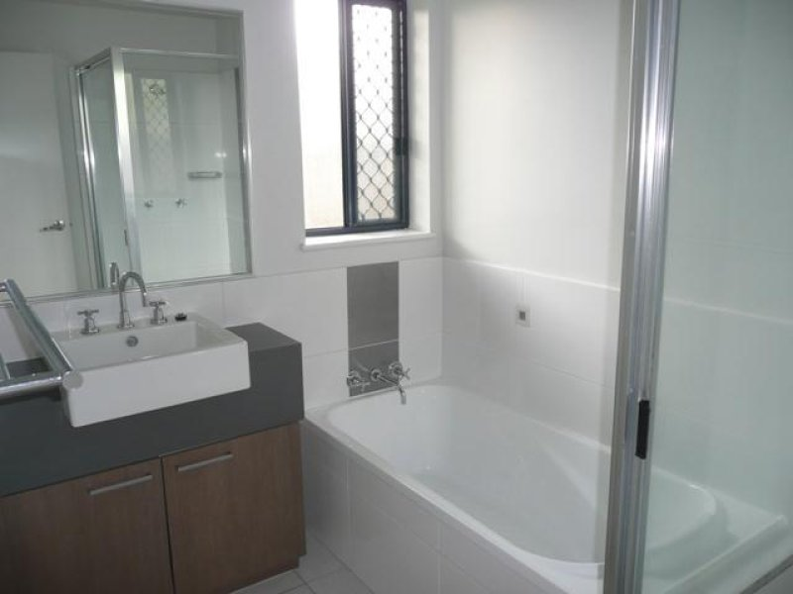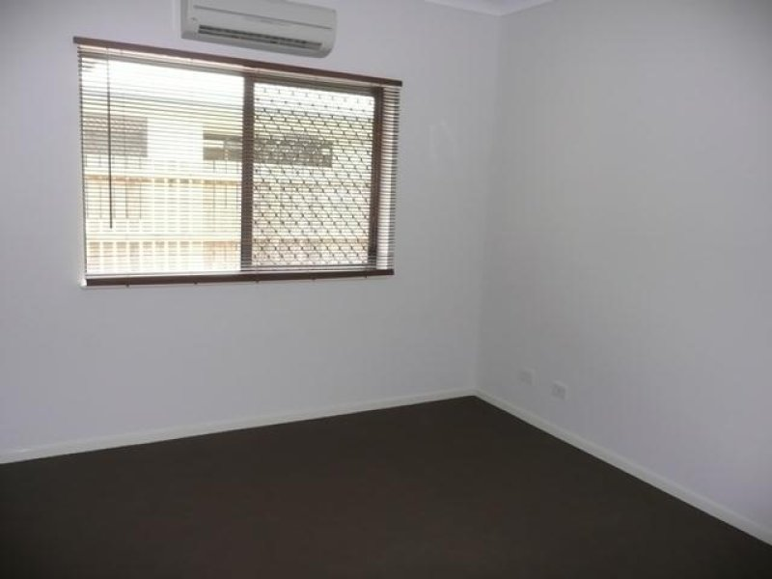$380 per week

- 4 bedrooms/2 bathrooms/Internal Laundry  
-Separate living area from main lounge  
- Modern kitchen & bathrooms  
-Tiled main areas and carpets to bedrooms  
-Modern lighting and completely rewired   
-Fully Air-Conditioned  
-Block home with security screens to all door and windows  
-Good size yard on a corner block fully fenced  
-Double garage with remote access  
-Pets on application  
-Close to Sugar land shopping Centre